**Component Name**: Image Selector

**Component Functionality**:

There is a list of images with scroll, initially the first image is selected and shown in larger box. When we click on larger image there is an image preview on full screen. We can click on images below and it will be selected and displayed in larger box. The selected image has border around it.

**Usage Areas**:

Can be useful to integrate in web application which displays components and its screenshots.

Ex. FED FastLane

**Component Technical details**:

* Angular cli version 9.1.6
* Typescript version 3.8.3
* rxjs version: 6.5.4

There are two components in the current app.

One is app component & one is dialog component.

1. app.component contains image selection functionality
2. image.dialog component contains image preview functionality.

**How this component can be integrated with other Applications**:

We can refer code / utilise same code to integrate the Image Selector.

**Screenshots**:

1. **Initial screen**:

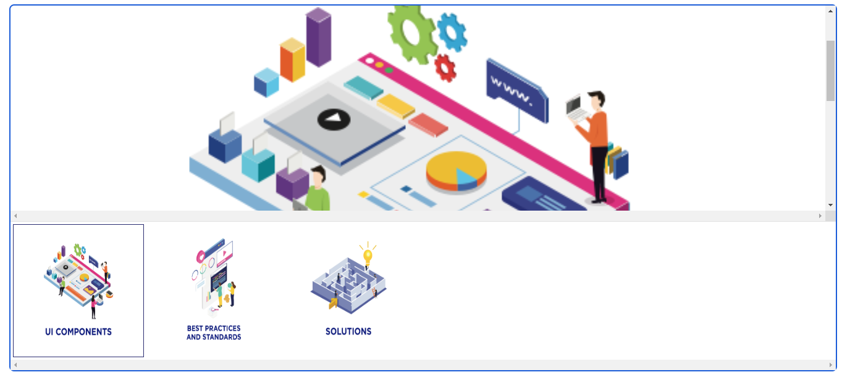

1. **Click on selected image it will show in full screen:**

